Team 3 Replication Memo

Non-Market Values in a Cost-Benefit World
A Replication of Eppink et al. (2016)
Daniel T. · Alistair K. · Matthew S. · Sam W.
ECON S5560 · Team 3 · Draft memo · 11 October 2026
Abstract. Eppink et al. (2016) test whether showing decision-makers dollar values for some impacts of a development, and not others, shifts the weight those impacts receive. They base this on a choice experiment with 164 New Zealand councillors and staff. We rebuilt their analysis from the published data, which came with no code. We reproduce the estimation samples, all 36 Figure 1 bars and 20 of 24 conditional-logit coefficient/p-value pairs exactly; the remaining four look like reporting errors. The match, however, requires an undisclosed, non-standard grouping of the data. Under the standard grouping, every monetary-information effect keeps its sign, but only one is significant at 5%. The mixed-logit results vary with the simulation draws, especially for councillors. For planners, the evidence is directional, not precise: priced impacts probably gain weight, so unpriced impacts need deliberate attention.

1 Introduction: the problem and the paper
Decision-makers usually see mixed information. Development revenue comes as a number, while effects on water, landscape or heritage are described in words. Kallis et al. (2013) ask whether monetary values cause "complexity blinding" by crowding out other ways of expressing value. Eppink et al. (2016) turn that question into a testable hypothesis. In a survey of New Zealand regional and district councillors and staff, respondents chose between two hypothetical urban-expansion projects and a status quo. Each option was described by its development level, its stream water quality and its impact on a historic tavern ("The Stables"). Respondents were randomly assigned to three information treatments: T1 shows only qualitative descriptions; T2 adds the district revenue of each development level ($1M, $2M or $3M); T3 also adds the well-being loss from worse water quality ($250k or $500k). Heritage is never priced.
The authors conclude that monetary information "strengthens preferences". Revenue figures reinforce the preference for development, and dollar-valued water losses reinforce the aversion to degraded water. Their policy implication is that presenting dollar values for only some variables makes decision-makers likely to focus on those variables. Our replication asks a narrower question: can the published results be reproduced from the published data, and do they survive reasonable alternative modelling choices? We keep the paper's conclusions separate from what our own evidence supports.

2 Reproducibility: what we did

2.1 Data access and sample construction
The only replication material is the public S1Table.DTA (CC BY 4.0). It has 2,160 rows covering 180 respondents, one row per alternative shown (4 cards × 3 alternatives each), with a flag marking the chosen alternative. No code was published, so we rebuilt every step in Python. Two samples had to be reverse-engineered. First, the paper's N of 1,968 implies 164 respondents, which no obvious filter produces (the "finished" flag gives 171). The raw answer columns show that 16 respondents answered fewer than four cards, and the file fills their missing cards with duplicate copies of cards they did answer. Excluding them gives exactly 164 respondents, 656 choice occasions and 1,968 rows, with 57, 52 and 55 respondents in T1–T3. Second, the role code identifies 121 councillors, two short of the 123 implied by the councillor N of 1,476. Two respondents who chose "Other" wrote "Mayor" and "Councillor but also Resource Consent Hearing Commissioner". Classifying both as elected members gives 123 (1,476 rows), consistent with the paper's statement that 75% of completed surveys came from councillors.
Table 1 and the estimation tables use different denominators. Table 1 matches all 180 respondents in the file (each item using its own available responses), not the 164-person estimation sample (Table A1). Table A2 gives the attribute coding.

2.2 Methods and implementation
Both models in the paper are random-utility models (McFadden, 1974; Train, 2009). Each alternative's utility is a linear index of seven main-effect dummies (three development levels, two water levels, two heritage levels) and five interactions between attribute levels and an indicator that monetary information was shown for that attribute. Development interactions are on in T2 and T3; water interactions only in T3. Because the status quo has all variables equal to zero, each coefficient measures attractiveness relative to "no change". The five interactions are the treatment effects that answer the research question. The conditional logit (CL) assumes one coefficient vector for everyone and gives logit choice probabilities. The panel mixed logit (ML) lets each respondent's coefficients follow independent normal distributions and ties together each person's four choices. Its likelihood has no closed form, so it is estimated by maximum simulated likelihood with Halton draws (Train, 2009, chs. 6 and 9; Hole, 2007). The paper used 500 shuffled Halton draws in Stata.
We estimated the CL two ways (Table A3, Figure A3). The paper specification treats each of the 12 design cards as one choice group, pooling every respondent who answered that card. It is the only grouping we found that reproduces the published numbers, and the paper does not report it. The standard specification treats each respondent's answer to one card as one choice among three alternatives, the textbook McFadden setup. We cluster its standard errors by respondent because each person answers four cards (Cameron & Miller, 2015). Our own ML estimator uses 500 scrambled Halton draws and normal coefficients on all 12 variables. Because simulated estimates depend on the draws, we re-estimated each ML model with 20 different draw sequences. For Figure 2 we computed each respondent's posterior-mean coefficients (Train, 2009, ch. 11). The code is four short scripts, and the CL results were cross-checked in R (survival::clogit).

2.3 What we reproduced and what we could not
Table 1 (Table A1). Nine of 13 shares (gender, age and residence) match to one decimal. The four city-size shares do not match any sample in the file. Figure 1 (Figure A1). All 36 bars (12 cards × 3 treatments) match exactly; treatment totals are 228, 208 and 220 answered cards. This confirms the reconstructed 164-person sample. Table 3, CL (Table A3). Using the paper's grouping, 20 of 24 coefficient/p-value pairs match to three decimals, as do both log likelihoods (−852.9 and −647.0). Our tolerance was 0.0015 on each value. The four mismatches are discussed in Section 3.5. Table 3, ML. These results can only be approximately matched. Our fit for all respondents is close to the published one (log likelihood −425.6 against −421.92), with the same signs and similar magnitudes. Across 20 draw sequences, 21 of the 24 published ML coefficients fall within our range of estimates. The councillor-only model (column 4) is unstable: its estimates vary several-fold across draw sequences, and in our seed-0 run the headline low-water × $ effect is −0.40 (p = 0.88), not the published −8.65 (p = 0.015). Figure 2 (Figure A2). We reconstruct the individual-level distributions from our model-3 run and treat them as an approximation, because they depend on the simulation draws.

3 Appraisal: methods and academic audience

3.1 Identification and experimental design
Random assignment of the information treatments is the design's main strength. Within the sample, differences between arms can be attributed to the information shown. The raw data already move in the predicted direction: low-water alternatives were chosen 3.8% of the time in T3 against about 7% in T1 and T2. External validity is weaker: the 17.4% response rate implies self-selection, about 55 respondents per arm limits power, and the choices are hypothetical, a central validity concern in stated-preference guidance (Johnston et al., 2017). The design also limits what T3 identifies. Development prices appear in both T2 and T3, and the model forces their effect to be equal across the two, so the water interaction measures adding water prices to development prices, not pricing water alone. When we let the development interactions differ between T2 and T3, the commercial interaction is 0.83 (p = 0.07) in T2 but 0.16 (p = 0.73) in T3, and the low-water interaction weakens to −1.12 (p = 0.13). "No development" appears only in the status quo, so the development coefficients combine preference for development with a general preference for taking any action. With no cost attribute, the coefficients are decision weights, not willingness to pay. The paper's abstract also states that cultural impacts "did not affect respondents' choices". Yet the Stables-and-landscape coefficient is negative and significant in the published column 1 and in our standard specification (−1.00, p = 0.015). The defensible claim is narrower: the unpriced heritage impact carried less weight than the priced attributes.

3.2 Choice-set definition and statistical inference
The grouping the paper used to reproduce its CL table is our most consequential finding. A conditional logit should compare each chosen alternative with the others on the same person's card. Pooling all answers to a design card instead models the probability of the whole set of chosen rows in that group, which is not the model the paper writes down. The fit statistics give it away. A model that assigns probability one-third to each alternative has log likelihood 656 × ln(1/3) = −720.7, and a correctly specified CL on three-alternative cards cannot fit worse than that. The published −852.9 does fit worse, while the standard specification gives −485.2 (councillors: −372.2 against a null of −540.5). Under the standard grouping, the main effects roughly halve (for example, low water goes from −6.14 to −3.82). The five treatment effects keep their signs and are similar in size or larger (Figure A3, Panel A). Their precision changes, however. With respondent-clustered errors, only residential × $ is significant at 5% (0.84, p = 0.039). The water interactions are borderline (medium −0.58, p = 0.084; low −1.02, p = 0.100), and none of the five reach 5% for councillors alone. Clustering matters because a person's four answers are not independent (Cameron & Miller, 2015).
Magnitudes need care for two reasons. First, logit coefficients are identified only relative to the variance of the unobserved error, so coefficients from different specifications or samples are not directly comparable (Swait & Louviere, 1993; Train, 2009). Ratios within a model are more meaningful. Low-water × $ is 15% of the low-water main effect under the paper's grouping and 27% under the standard grouping. For the same reason, the paper's statement that the councillor models "are improvements" because their log likelihoods are higher is not valid: log likelihoods from samples of different sizes cannot be compared. Second, the CL imposes independence of irrelevant alternatives (IIA). The authors say they could not confirm IIA and so estimated ML models, but they report no test, and we did not run one (Hausman & McFadden, 1984).

3.3 Mixed-logit robustness
The ML relaxes IIA and lets preferences differ across people, but it adds assumptions (all 12 coefficients independent and normal, which allows implausible signs) and simulation noise. Hole (2007) describes simulated estimation with Halton draws and stresses checking that results are stable as draws change. Figure A3, Panel B shows that they are not fully stable here. For all respondents, our 20 runs bracket most published values (all 12 fall inside our range, and our log likelihoods of −427.4 to −419.3 bracket the published −421.92, although low-water × $ still ranges from −13.4 to −3.8). For councillors, 24 parameters are estimated from 123 people and 492 choices, and results vary widely: three published coefficients fall outside our range, 3 of 20 runs did not converge, and the low-water × $ coefficient runs from −26.9 to −0.4 (median −6.9). This range is simulation sensitivity, not a confidence interval: it shows how much the answer moves because of arbitrary computational choices, before any sampling uncertainty. The paper's strongest councillor-level result cannot be pinned down within that noise. Figure 2 is labelled model 4, but its panels match model 3 more closely; we treat that attribution as an inference. Its dotted lines are the 2.5th–97.5th percentiles of respondents' posterior-mean coefficients. They are not a 95% confidence interval for a treatment effect, so they cannot support the paper's statement that "95% of respondents who were shown monetary information have a stronger tendency" toward the attribute.

3.4 Relation to the literature
The paper adds field evidence from real decision-makers to the debate summarized by Kallis et al. (2013). Their argument is that the question is not whether to value nature in money, but under what conditions monetary valuation helps or harms decisions. One such condition is whether prices crowd out unpriced values. Eppink et al.'s design, with priced and unpriced attributes in the same choice, suits that question well. Judged against contemporary stated-preference guidance (Johnston et al., 2017), the study is thin on several of the points that guidance emphasizes: sample representativeness and nonresponse, consequentiality of the choice task, the source of the monetary values shown, and full reporting of design and estimation. The water-loss figures were chosen to be "significant, but not overly large" rather than taken from a valuation study, and the undisclosed grouping, unreported IIA test and ambiguous model labels fall short of transparent reporting. On methods, the paper's random-utility framework and its use of the ML follow standard practice (McFadden, 1974; Train, 2009; Hole, 2007). However, inference that accounts for repeated choices (Cameron & Miller, 2015) and caution about comparing scales (Swait & Louviere, 1993) would have made the treatment effects more credible.

3.5 Reporting discrepancies and limits of our diagnosis
We separate what we observe from how we explain it. Observed: (i) In column 2, the two water coefficients are printed as −0.393 and −0.602; the data give −3.891 and −6.184, whose standard errors are 0.393 and 0.602. (ii) Column 1's residential × $ is printed as 0.670 (p = 0.018); the data give 0.699 (p = 0.018), and with the same standard error 0.670 would give p = 0.023. (iii) Column 1's Stables-and-landscape p-value is printed as 0.031; the data give 0.001. (iv) Column 4's residential × $ is marked ** with p = 0.062. (v) The four city-size shares in Table 1 do not match the file. (vi) Figure 2 is labelled as model 4. Explanations: (i) looks like standard errors printed in coefficient cells. (ii) looks like a transcription error, because the printed p-value fits our coefficient. (iii) equals the p-value from the same model on all 180 respondents, so it may be left over from an earlier run. (iv) contradicts the table's own legend. For (v), the published shares are whole-number counts only if n is 188 (69/58/40/21), while 169 respondents in the file answered the question. This suggests a larger version of the data, but it does not show which dataset the authors used. Less important, "15 individuals are randomly dropped" in each Halton draw most likely describes discarding the first 15 draws, a common software default. None of these explanations is confirmed by the authors. Matching a standard error is evidence of a possible reporting problem, not proof.

3.6 Remaining checks
In order of priority: (1) ask the authors for their code, which would settle the grouping, the Figure 2 model and the Table 1 sample; (2) estimate the ML in Stata's mixlogit with the paper's settings, if a licence is available; (3) run IIA diagnostics (Hausman & McFadden, 1984); (4) explore more treatment contrasts, building on the T2/T3 split in Section 3.1, and try alternative ML specifications such as correlated or fixed coefficients. We have not done (1)–(3). Agreement on selected numbers does not prove our code is error-free.

4 Recommendations: real-world audience
Intended reader. The planning committee of a regional council, and the staff who prepare its decision reports on development applications with water-quality and heritage impacts.

4.1 Main takeaway
How information is presented can tilt decisions. Councillors who saw a dollar figure for an impact gave it somewhat more weight than colleagues who saw it in words: revenue made development more attractive, and a dollar loss made polluted water less attractive. We are fairly confident about the direction of this effect, because it appears under both ways of grouping the data and in nearly every simulation run. We are not confident about its size, which depends on modelling choices the paper did not disclose, and in the standard analysis most individual effects are not statistically significant. Treat this as a well-founded caution, not a measured bias.

4.2 Recommended actions
- Present priced and unpriced impacts side by side, in the same format. Put every material impact in one summary table with equal visual weight, priced or not. The treatment effects (Figure A3, Panel A) suggest a lone dollar figure draws attention to itself.
- Where credible values exist, price both sides. If a report gives a dollar value for revenue, it should give an equally rigorous value for environmental losses where one exists, or say that none is available. Pricing water losses moved choices away from polluted options (Section 3.1).
- Do not force a price on everything. Heritage and cultural values may be impractical or inappropriate to monetize (Kallis et al., 2013; Eppink et al., 2016). Describe them prominently and say why they matter, rather than leaving them as a footnote to the dollar figures.

4.3 Cautions and conclusion
The evidence comes from a hypothetical 2015 survey of 164 New Zealand decision-makers, with a 17.4% response rate and dollar figures chosen by the researchers. It cannot tell this committee what local water quality or heritage is worth, how large the effect would be for its own members, or whether it changes real approval decisions. The practical conclusion: when a staff report puts a dollar figure on development revenue but not on environmental or cultural costs, the committee should treat that report as incomplete. Before voting, it should ask for the unpriced impacts to be summarized alongside the priced ones.

References
Cameron, A. C., & Miller, D. L. (2015). A practitioner's guide to cluster-robust inference. Journal of Human Resources, 50(2), 317–372. https://doi.org/10.3368/jhr.50.2.317
Eppink, F. V., Winden, M., Wright, W. C. C., & Greenhalgh, S. (2016). Non-market values in a cost-benefit world: Evidence from a choice experiment. PLOS ONE, 11(10), e0165365. https://doi.org/10.1371/journal.pone.0165365
Hausman, J., & McFadden, D. (1984). Specification tests for the multinomial logit model. Econometrica, 52(5), 1219–1240. https://doi.org/10.2307/1910997
Hole, A. R. (2007). Fitting mixed logit models by using maximum simulated likelihood. The Stata Journal, 7(3), 388–401. https://doi.org/10.1177/1536867X0700700306
Johnston, R. J., Boyle, K. J., Adamowicz, W. (V.), Bennett, J., Brouwer, R., Cameron, T. A., Hanemann, W. M., Hanley, N., Ryan, M., Scarpa, R., Tourangeau, R., & Vossler, C. A. (2017). Contemporary guidance for stated preference studies. Journal of the Association of Environmental and Resource Economists, 4(2), 319–405. https://doi.org/10.1086/691697
Kallis, G., Gómez-Baggethun, E., & Zografos, C. (2013). To value or not to value? That is not the question. Ecological Economics, 94, 97–105. https://doi.org/10.1016/j.ecolecon.2013.07.002
McFadden, D. (1974). Conditional logit analysis of qualitative choice behavior. In P. Zarembka (Ed.), Frontiers in econometrics (pp. 105–142). Academic Press.
Swait, J., & Louviere, J. (1993). The role of the scale parameter in the estimation and comparison of multinomial logit models. Journal of Marketing Research, 30(3), 305–314. https://doi.org/10.1177/002224379303000303
Train, K. E. (2009). Discrete choice methods with simulation (2nd ed.). Cambridge University Press. https://eml.berkeley.edu/books/choice2.html
Template structure reference (not one of the topical sources): Korpershoek, J., Musumeci, M., Stans, R. A., & Totarelli, M. (2023). Teacher influence in music composition since 1450: A replication of Borowiecki (2022). I4R Discussion Paper No. 27. https://hdl.handle.net/10419/270744

Attribution, AI use and submission notes

Team attribution
Member | Charter role | Contribution
Daniel T. | Writing/presentation; note-taker and organizer | [Daniel to confirm his contribution before submission]
Alistair K. | Data analysis | [Alistair to confirm his contribution before submission]
Matthew S. | Data analysis | Built and maintains the replication repository (data parsing, CL and ML estimation, discrepancy diagnosis, dashboard and simplified replication scripts) and assembled this draft. [Matthew to confirm]
Sam W. | Point of contact; writing/presentation | [Sam to confirm his contribution before submission]

AI-use disclosure
Following the team charter, AI was used as a coding and writing assistant, and team members are responsible for verifying its output. Claude (Anthropic) drafted the replication code, the simplified replication scripts, the dashboard, the documentation and the prose of this draft memo. OpenAI Codex organized the original memo template and the submission package. All numbers in this memo come from our code's output on the authors' public data. All cited sources must be checked by a team member before submission.

Exhibit provenance
Unless stated otherwise, exhibits were produced by the team's simplified replication scripts (Simple-Replication/, repository revision b2e3cb4) run on S1Table.DTA. Table 1 and Figure 1 comparisons come from Data-Parsing/ outputs at the same revision. Published values are reproduced from Eppink et al. (2016), CC BY 4.0.

Exhibits

Table A1. Respondent characteristics (share of respondents, %)
Characteristic | Published | Ours: all 180 in file | Ours: 164 estimation sample
Gender
Female | 32.5 | 32.5 | 31.9
Male | 67.5 | 67.5 | 68.1
Age
<40 | 8.4 | 8.4 | 8.0
40–49 | 14.8 | 14.8 | 14.7
50–59 | 27.7 | 27.7 | 28.7
60–69 | 36.8 | 36.8 | 36.7
>70 | 12.3 | 12.3 | 12.0
Personal residence
Rural | 41.8 | 41.8 | 41.5
Urban | 58.2 | 58.2 | 58.5
City inhabitants
>50,000 | 36.7 | 39.1 | 40.4
15,001–50,000 | 30.9 | 29.0 | 28.2
5,000–15,000 | 21.3 | 20.1 | 19.2
<5,000 | 11.2 | 11.8 | 12.2
Published Table 1 compared with the S1 data file. Each item uses its available-response denominator. Shading marks mismatches. Source: Eppink et al. (2016), Table 1; Data-Parsing/02_descriptives.py.
Gender, age and residence match the published shares exactly when computed on all 180 respondents in the file, not the 164 used for estimation. The 164-person column differs by up to one percentage point, which shows that Table 1 describes everyone who started the survey. City size does not match either sample. Its published shares are whole-number counts only for n = 188, more than the 169 respondents who answered that question. The source of these four values remains unresolved.

Table A2. Attributes, levels and treatment coding
Attribute | Level | Description (paraphrased) | Monetary information | Model variables | Rows shown
Development | None (status quo) | No rezoning; growth goes elsewhere | — | Base | 656
 | Limited | Half of growth housed; low-density | $1,000,000 revenue (T2, T3) | limited; limited × $ | 441
 | Residential | All growth housed; medium-density | $2,000,000 revenue (T2, T3) | residential; residential × $ | 486
 | Residential & commercial | All growth plus shops and a 'super store' | $3,000,000 revenue (T2, T3) | commercial; commercial × $ | 385
Water quality | High | Clear; game fish; swimmable | No loss (T3) | Base | 1,093
 | Medium | Slightly murky; not swimmable | $250,000 well-being loss (T3) | water medium; medium × $ | 491
 | Low | Very murky; unsafe | $500,000 well-being loss (T3) | water low; low × $ | 384
Cultural heritage | None | Tavern remains solitary; views unaffected | Never priced | Base | 987
 | Stables | Development surrounds the tavern | Never priced | stables | 444
 | Stables & landscape | Tavern surrounded and views disturbed | Never priced | stables & landscape | 537
Team coding of the published Table 2 (paraphrased level descriptions). "Rows shown" counts alternatives displayed in the 1,968-row estimation sample, including the status quo. These are options shown, not options chosen. Source: Eppink et al. (2016), Table 2; Simple-Replication/step1_prepare_data.py.
The status quo (no development, high water, no heritage impact) is the base level, so it has no coefficient. Development revenue is shown in T2 and T3, and water-quality losses only in T3. Heritage was deliberately left unpriced, so there is no heritage × $ term. "No development" occurs only in the status quo, which is why the development main effects also capture a general preference for change.

Figure A1. Responses per choice scenario
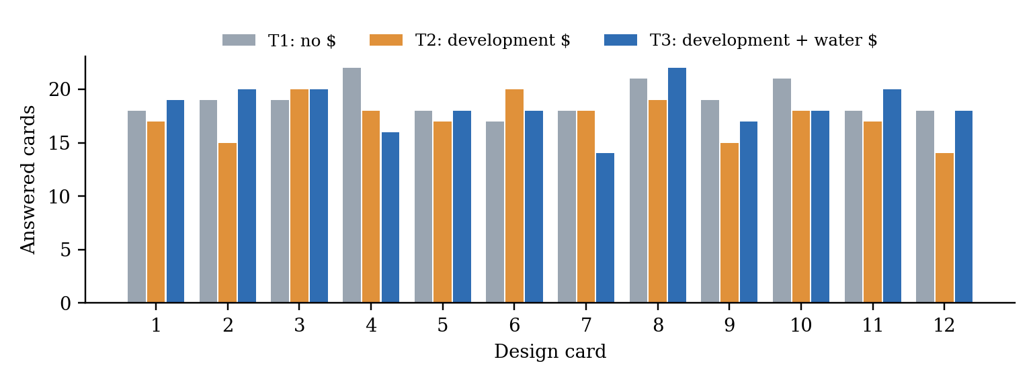
Team reproduction of published Figure 1: answered cards by design card and treatment. Totals are 228 / 208 / 220 from 57 / 52 / 55 complete respondents. All 36 bars equal the published values. Source: Simple-Replication/clean_data.csv; Eppink et al. (2016), Figure 1.
All 36 bar heights match. That is strong evidence that the 164-respondent sample, and the exclusion of the 16 respondents whose missing cards were filled with duplicates, is the one the authors used.

Table A3, Panel A. Published regression results (Eppink et al., 2016, Table 3)
 | (1) CL All | (2) CL Councillors | (3) ML All | (4) ML Councillors
Main effects: development
Limited | 4.260*** (0.000) | 4.114*** (0.000) | 6.819*** (0.002) | 6.878** (0.011)
Residential | 4.553*** (0.000) | 4.545*** (0.000) | 6.259*** (0.006) | 6.554** (0.013)
Commercial | 4.112*** (0.000) | 4.184*** (0.000) | 6.387*** (0.002) | 6.663*** (0.005)
Main effects: water quality
Medium | −3.954*** (0.000) | −0.393*** (0.000) | −7.324*** (0.000) | −7.578*** (0.000)
Low | −6.135*** (0.000) | −0.602*** (0.000) | −14.950*** (0.000) | −19.020*** (0.001)
Main effects: cultural
Stables | −0.822* (0.080) | −0.758 (0.150) | −1.239 (0.294) | −2.131 (0.244)
Stables & landscape | −1.672** (0.031) | −1.850*** (0.001) | −2.765* (0.080) | −2.366 (0.164)
Treatment effects (monetary information shown): development
Limited | 0.205 (0.452) | 0.084 (0.790) | 1.290 (0.187) | 2.650 (0.109)
Residential | 0.670** (0.018) | 0.647* (0.058) | 3.222** (0.015) | 3.450* (0.062)
Commercial | 0.308 (0.282) | 0.254 (0.433) | 1.754* (0.082) | 2.225 (0.166)
Treatment effects (monetary information shown): water quality
Medium | −0.473* (0.076) | −0.299 (0.323) | −2.272* (0.064) | −2.085 (0.135)
Low | −0.919* (0.082) | −0.592 (0.286) | −4.305** (0.018) | −8.649** (0.015)
Log likelihood | −852.9 | −647.0 | −421.92 | −316.4
N | 1,968 | 1,476 | 1,968 | 1,476
Reproduced from Eppink et al. (2016), Table 3, doi:10.1371/journal.pone.0165365.t003, CC BY 4.0. p-values in parentheses; * p < 0.1, ** p < 0.05, *** p < 0.01. Shaded cells are those discussed in Section 3.5. Values are preserved as printed.

Table A3, Panel B. Team replication results
 | (1) CL All  paper grouping | (2) CL Coun.  paper grouping | (3) ML All  500 draws | (4) ML Coun.  500 draws | CL All  standard | CL Coun.  standard
Main effects: development
Limited | 4.260*** (0.000) | 4.115*** (0.000) | 5.663*** (0.007) | 13.638** (0.021) | 2.235*** (0.001) | 2.250*** (0.002)
Residential | 4.553*** (0.000) | 4.545*** (0.000) | 5.653** (0.011) | 18.697** (0.019) | 2.337*** (0.000) | 2.403*** (0.000)
Commercial | 4.112*** (0.000) | 4.184*** (0.000) | 6.228*** (0.004) | 14.928** (0.019) | 2.174*** (0.000) | 2.287*** (0.000)
Main effects: water quality
Medium | −3.954*** (0.000) | −3.891*** (0.000) | −7.045*** (0.000) | −17.625*** (0.009) | −2.227*** (0.000) | −2.251*** (0.000)
Low | −6.135*** (0.000) | −6.184*** (0.000) | −14.975*** (0.001) | −34.936** (0.013) | −3.818*** (0.000) | −3.927*** (0.000)
Main effects: cultural
Stables | −0.822* (0.080) | −0.758 (0.150) | −0.951 (0.435) | −4.104 (0.156) | −0.406 (0.336) | −0.402 (0.386)
Stables & landscape | −1.673*** (0.001) | −1.850*** (0.001) | −1.874 (0.154) | −7.365* (0.056) | −0.999** (0.015) | −1.138** (0.011)
Treatment effects (monetary information shown): development
Limited | 0.205 (0.452) | 0.084 (0.790) | 2.229 (0.119) | 5.431* (0.069) | 0.397 (0.273) | 0.250 (0.554)
Residential | 0.699** (0.018) | 0.647* (0.058) | 2.671** (0.038) | 2.401 (0.260) | 0.836** (0.039) | 0.754 (0.103)
Commercial | 0.308 (0.282) | 0.254 (0.433) | 1.179 (0.267) | 1.919 (0.479) | 0.512 (0.191) | 0.429 (0.361)
Treatment effects (monetary information shown): water quality
Medium | −0.473* (0.076) | −0.299 (0.323) | −1.873 (0.144) | −2.859 (0.205) | −0.584* (0.084) | −0.364 (0.346)
Low | −0.919* (0.082) | −0.592 (0.286) | −3.813* (0.070) | −0.397 (0.879) | −1.023 (0.100) | −0.645 (0.329)
Log likelihood | −852.9 | −647.0 | −425.6 | −314.5 | −485.2 | −372.2
N (rows) | 1,968 | 1,476 | 1,968 | 1,476 | 1,968 | 1,476
CL columns use the paper's design-card grouping. ML columns use 500 scrambled Halton draws (seed 0). Standard-specification columns group by respondent × card, with p-values clustered by respondent. p-values in parentheses. Shaded CL cells differ from Panel A. Source: Simple-Replication/step3_conditional_logit.py, step4_mixed_logit.py.
The paper-grouping CL columns reproduce Panel A except for the four shaded cells (Section 3.5). The ML columns come from a single simulation run and should be read together with Figure A3, Panel B. The standard-specification columns are our preferred CL estimates. Their main effects are about half as large, but the treatment effects keep their signs, and among them only residential × $ (all respondents) is significant at 5%.

Figure A2. Individual monetary-information effects
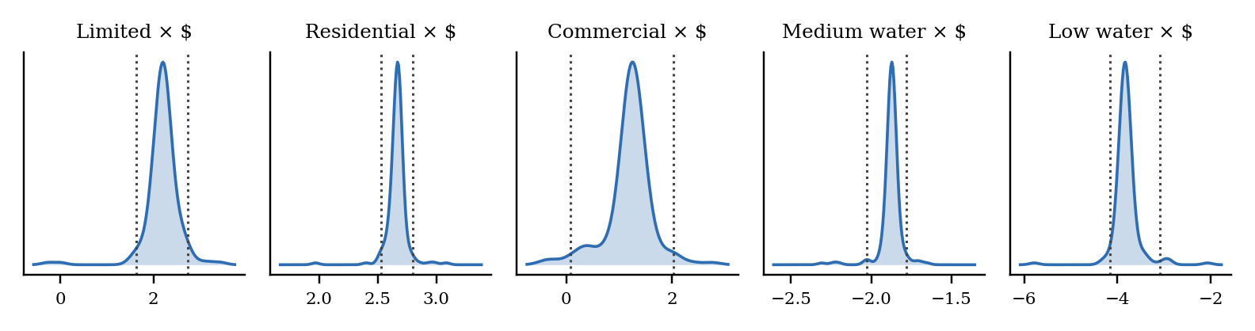
Team reconstruction of published Figure 2 from model 3 (all complete respondents, 500 scrambled Halton draws, seed 0). Curves are densities of respondent-specific posterior-mean coefficients. Dotted lines mark their 2.5th and 97.5th percentiles; this is not a confidence interval for a treatment effect. The published text names model 4; our attribution to model 3 is an inference. Source: same model as Simple-Replication/step4_mixed_logit.py.
In our reconstruction, 98–100% of respondents' coefficients lie on the same side of zero as the corresponding Table 3 coefficient, and each distribution is centred close to it. The distributions are narrow for two reasons. Each respondent makes only four choices, which pulls their estimated coefficients toward the population mean. In addition, a price interaction never enters the likelihood of a respondent whose treatment did not show that price, so for those respondents the estimate is essentially the population mean. The concentration around the mean is therefore partly a mechanical feature of the model. It is not independent evidence that individual respondents reacted to prices.

Figure A3. Specification and simulation sensitivity
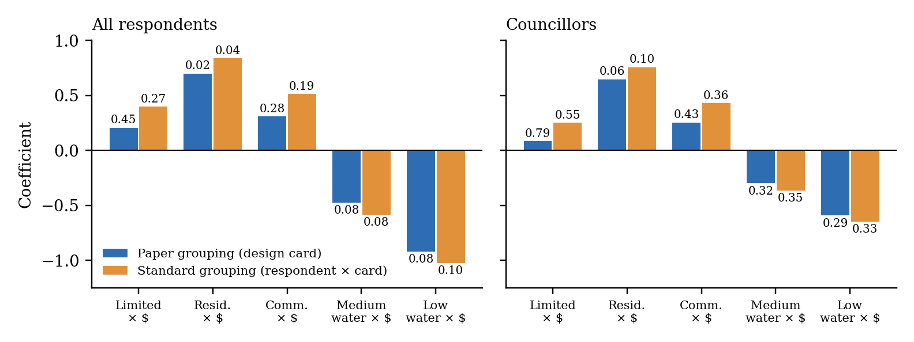
Panel A. The five monetary-information effects under the paper's design-card grouping and the standard respondent × card grouping, by sample. Labels give p-values (standard: clustered by respondent). Source: Simple-Replication/results_conditional_logit.csv.
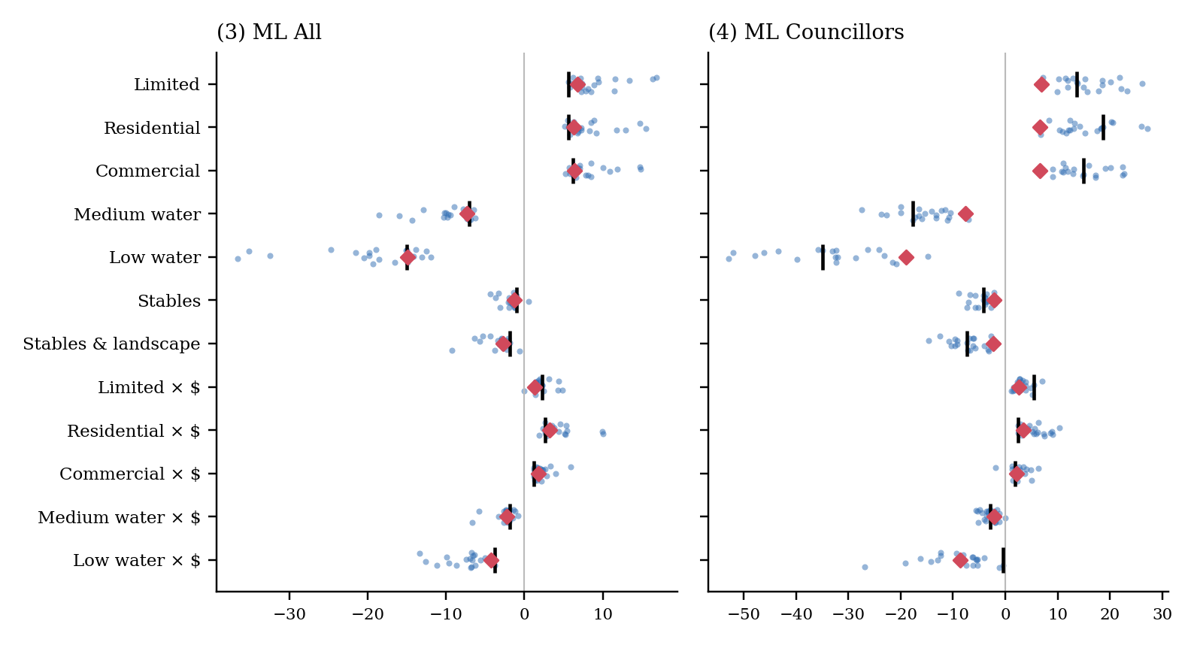
Panel B. Mixed-logit coefficients from 20 draw sequences of 500 scrambled Halton draws each (dots), our seed-0 estimate (bar) and the published value (diamond). The spread is simulation sensitivity, not a confidence interval.
Robustness conclusion. The direction of every monetary-information effect survives the change of grouping, and in the mixed logit it holds in nearly every draw sequence (a few runs flip limited × $ for all respondents and commercial × $ for councillors). Statistical strength does not survive. For a planning committee, this supports treating selective pricing as a real risk to balanced decisions, but it does not support quoting a specific size for that risk.

